# Executive Summary for Metrocar Customer Journey Funnel

## Introduction

In a bid to enhance user experience and operational efficiency, MetroCar has undertaken an extensive analysis of user behavior and ride patterns. This report delves into various aspects of user interaction and ride utilization, aiming to uncover insights that can drive strategic improvements and customer satisfaction.

## Objectives

### Primary Objectives

* Funnel Analysis: Identify stages in the user journey to improve and pinpoint specific drop-off points.
* Platform Insights: Analyze user interaction across iOS, Android, and Web platforms to inform marketing strategies.
* Age Group Segmentation: Understand performance and preferences of different age groups in the funnel.
* Surge Pricing Feasibility: Assess ride request patterns to evaluate the potential for surge pricing.

### Secondary Objectives

* Sentiment Analysis: Extract insights from user reviews to enhance service quality.
* Cancellation Timing Analysis: Investigate the average time between ride requests and cancellations.

## Methodology

The analysis was conducted using SQL and Python for data manipulation and visualization, focusing on Metrocar’s user data and customer feedback. The study includes funnel analytics, platform usage patterns, age group segmentation, time-based ride request distribution, and supplementary sentiment and cancellation timing analyses. Additionally, a Tableau dashboard was created to provide further understanding of the User and Ride level funnels.

## Key Findings

### Funnel Analysis & Conversion Optimization

Our comprehensive analysis of the user journey within the Metrocar service funnel revealed critical drop-off points, particularly from Ride Request/Driver Acceptance to Ride Completion, where only 50% of rides are completed. This finding is pivotal as it indicates that despite a healthy initial user sign-up rate, only 26% of these users complete a ride, highlighting a significant area for improvement in user retention and service delivery.

Figure : Metrocar User Funnel

### Platform Analysis

The data shows a dominant preference for the iOS platform among Metrocar users, with 234,693 users, reflecting its 58% market share in the US. This is particularly notable among Millennials and Gen Z demographics. Android and Web platforms follow with 112,317 and 38,467 users, respectively. This distribution, especially in the service area area, underscores the importance of focusing on iOS for targeted marketing strategies.

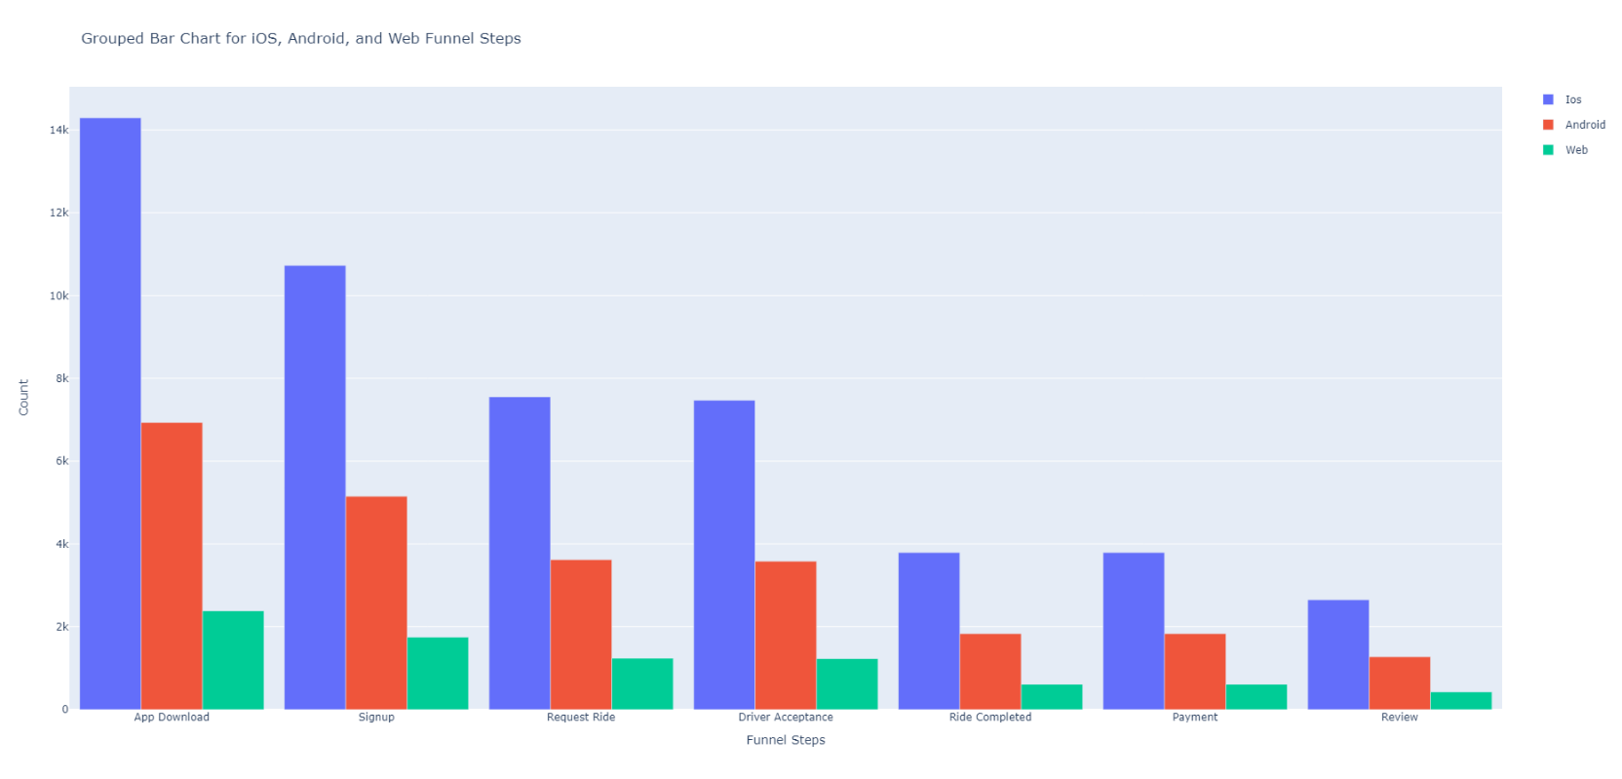

Figure : Platform Distribution

### Surge Pricing Feasibility

Analysis of ride request patterns indicates consistent peak times, particularly between 8 AM - 10 AM and 4 PM - 8 PM daily. This trend presents a strong case for considering surge pricing to manage demand and optimize revenue during these high-demand periods. A screenshot of a computer screen

Figure : Heatmap of Rides

### Age Group Segmentation

Ride completion statistics across different age groups reveal that the 35-44 age group has the highest completion rate (1,861), followed by the 25-34 and 18-24 age groups. With the age groups that are the most active on the platform and when the highest utilization takes place during the day it suggests that Metrocar is used primarily for work commutes. Interestingly, a significant number of users fall into the 'Unknown' category, suggesting a potential area for better data collection or targeted marketing strategies to engage these users more effectively. A graph of different colored bars

Figure : Age Distribution

### Cancellation Timing Analysis

The average time between a ride request and cancellation is 12 minutes and 33 seconds, with an average time to pickup of 14 minutes and 29 seconds. While these findings are inconclusive in determining the reasons for cancellation, they do provide a baseline for further investigation into user behavior and service response times.

### Review Sentiment Analysis

The sentiment analysis of customer reviews yielded a mixed response, with 71,690 positive, 69,668 negative, and 14,853 neutral reviews. The average sentiment scores across various topics such as Route & Duration Concerns, Driver Professionalism, and Reliability indicate varying levels of customer satisfaction and areas for service improvement. Further analysis in this area can uncover ways to improve driver training and identify weaknesses in the routing algorithm. A graph with blue squares

Figure : Sentiment by Topic

## Recommendations

### Funnel Analysis & Conversion Optimization

Understanding the significant drop-off between ride requests and completions is crucial. With a large number of account creations but a lower rate of ride completions, Metrocar has an opportunity to boost market share and revenue from its existing user base. The company should prioritize in-depth research, such as user surveys, focus groups, or analyses of competitor strategies, to uncover the underlying causes. Additionally, implementing a feedback mechanism for users who cancel rides will provide direct insights into their reasons for cancellation.

### Platform & Age Analysis

Metrocar should intensify its marketing efforts on the iOS platform, targeting the 25-44 age group, which shows the highest ride completion rates. While it's important not to neglect other platforms and age groups, focusing on the most engaged customer profile will enhance brand awareness among the demographics most likely to generate revenue.

### Surge Pricing

Implementing surge pricing during peak commute hours, specifically from 8-10 AM and 4-8 PM, could significantly strengthen revenue and increase driver availability, reducing wait times for rides. However, it's essential to actively monitor customer feedback to ensure that surge pricing doesn't lead to a significant drop in user numbers.

### Sentiment Analysis

The initial sentiment analysis suggests that Metrocar needs to focus on improving aspects such as Route Concerns, Billing Issues, Service Dissatisfaction, and Driver Professionalism. Enhancing driver training, refining the routing algorithm, and ensuring transparent billing practices are steps that could be taken. Understanding what customers value is key to effectively targeting resources to improve service quality and strengthen revenue.